**INTERNSIP REPORT**

|  |  |
| --- | --- |
| **Area Of Online Internship** | AI/ML/DL |
| **Intern Name** | APOORVA RATHORE |
| **Name Of Institution** | **INDIAN INSTITUTE OF TECHNOLOGY, INDORE** |
| **Faculty Mentor Name** | **Dr. Vimal Bhatia** |
| **Duration** | **3 MONTHS (13/01/2022 TO 13/04/2022)** |
| **Date Of Submission** | **30/04/2022** |

Table of contents:

Introduction:

SVM

Regression using Deep Neural Networks

U-Net

* Problem

Understanding the problem statement

Solution

**Introduction:**

**Regression Using Deep Neural Networks**

**Linear Regression** is a machine learning algorithm based on **supervised learning**. It performs a **regression task**. Regression models a target prediction value based on independent variables. It is mostly used for finding out the relationship between variables and forecasting. Different regression models differ based on – the kind of relationship between dependent and independent variables, they are considering and the number of independent variables being used. Linear Regression is the basic form of regression analysis. It assumes that there is a linear relationship between the dependent variable and the predictor(s).

Recent years have seen a surge in the use of Neural Networks for regression tasks. The purpose of using Artificial Neural Networks for Regression over Linear Regression is that the linear regression can only learn the linear relationship between the features and target and therefore cannot learn the complex non-linear relationship. In order to learn the complex non-linear relationship between the features and target, we are in need of other techniques. One of those techniques is to use Artificial Neural Networks. Artificial Neural Networks have the ability to learn the complex relationship between the features and target due to the presence of activation function in each layer. Following is a general depiction of Artificial Neural Networks.

The Artificial Neural Networks consists of the Input layer, Hidden layers, Output layer. The hidden layer can be more than one in number. Each layer consists of n number of neurons. Each layer will be having an Activation Function associated with each of the neurons. The activation function is the function that is responsible for introducing non-linearity in the relationship. In our case, the output layer must contain a linear activation function. Each layer can also have regularizers associated with it. Regularizers are responsible for preventing overfitting.

Artificial Neural Networks consists of two phases,

1. Forward Propagation

2. Backward Propagation

Forward propagation is the process of multiplying weights with each feature and adding them. The bias is also added to the result. Backward propagation is the process of updating the weights in the model. Backward propagation requires an optimization function and a loss function.

Following is an example of a neuron showing the inputs (x1, x2, ......, xn), their corresponding weights (w1, w2, ......, wn), bias(b) and the activation function f applied to the weighted sum of the inputs.



**U-Net**

The UNET was developed by Olaf Ronneberger et al. for Bio Medical Image Segmentation. The architecture contains two paths. First path is the contraction path (also called as the encoder) which is used to capture the context in the image. The encoder is just a traditional stack of convolutional and max pooling layers. The second path is the symmetric expanding path (also called as the decoder) which is used to enable precise localization using transposed convolutions. Thus it is an end-to-end fully convolutional network (FCN), i.e. it only contains Convolutional layers and does not contain any Dense layer because of which it can accept image of any size. Following is the architecture of a general U-Net architecture taken from the original paper:



U-net architecture (example for 32x32 pixels in the lowest resolution). Each blue box corresponds to a multi-channel feature map. The number of channels is denoted on top of the box. The x-y-size is provided at the lower left edge of the box. White boxes represent copied feature maps. The arrows denote the different operations.

***Problem:***

**Problem Statement:** In the given data the desired one has the symbols/information transmitted, which undergoes some sort of non-linear distortion and then we receive distorted one at the receiver. You have to apply a DL/ML block to estimate the desired signal from the distorted one. You can use 60% of the data for training and the rest for testing.

**Desired**: <https://docs.google.com/spreadsheets/d/1qc8o3hSkqWCIGYR5qSGDdXCtLS1O3GFN/edit?usp=sharing&ouid=115617273379612933162&rtpof=true&sd=true>

**Distorted**:

<https://docs.google.com/spreadsheets/d/1wNzG16ccgxr9dJh1pKE2iS2cpwkLg9qQ/edit?usp=sharing&ouid=115617273379612933162&rtpof=true&sd=true>

Dataset was provided by the institution.

**Pre-Processing**: The dataset provided is a two excel sheet containing the input and the output values. As part of pre-processing, the input values and output values were separated and stored in two different NumPy arrays.

**Solution**:

<https://colab.research.google.com/drive/1K7nD2_Y8rblnLOdTd7YsuU9Din6GOzN1?usp=sharing>

**Results Graph**:

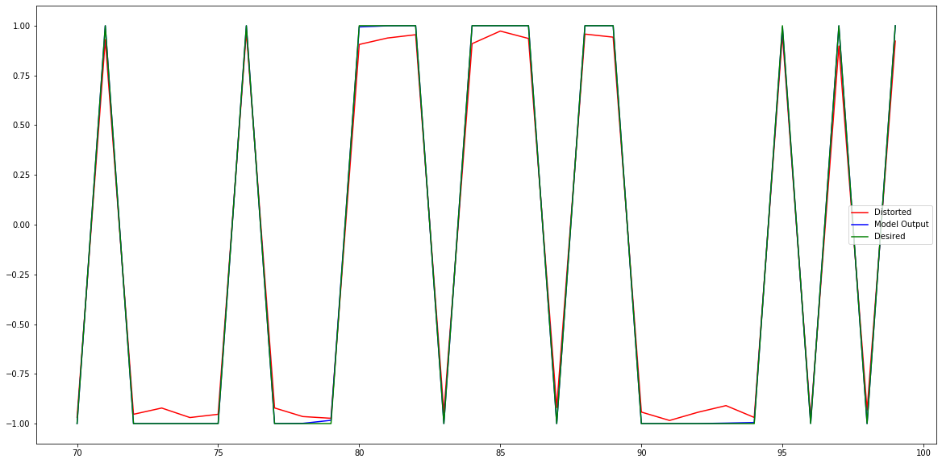

**Results:**

The best possible results were obtained for model with an MSE of 2.5402583226672207e-05.

**References**:

* <https://towardsdatascience.com/introduction-to-machine-learning-algorithms-linear-regression-14c4e325882a>
* <https://towardsdatascience.com/understanding-semantic-segmentation-with-unet-6be4f42d4b47>
* <https://medium.com/coinmonks/the-mathematics-of-neural-network-60a112dd3e05>
* <https://arxiv.org/pdf/1505.04597.pdf>